Percent of people live in poverty

The suburban of the 4 most populous metropolitan statistical areas in North Carolina, Charlotte, Raleigh, and Greensboro, and Fayetteville, tend to have lower poverty rate compared to the rest of the state. This shows that the suburban area of a large city tends to have lower poverty rate compared to urban and rural areas.

Percent of people who speak English less than well

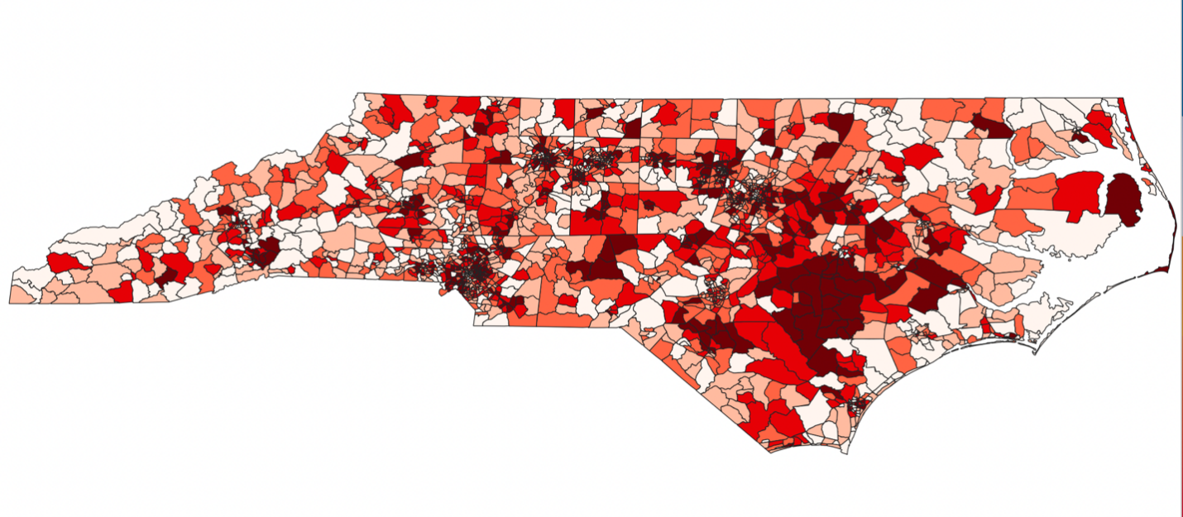

Percent of people who are minority

From the 2 graphs above, we can see that there is a relatively strong relationship geographically between the Percent of people who speak English less than well and the Percent of people who are minority.